**CLICK LAUNCH INSTANCE AND SELECT WINDOWS IN AMI**

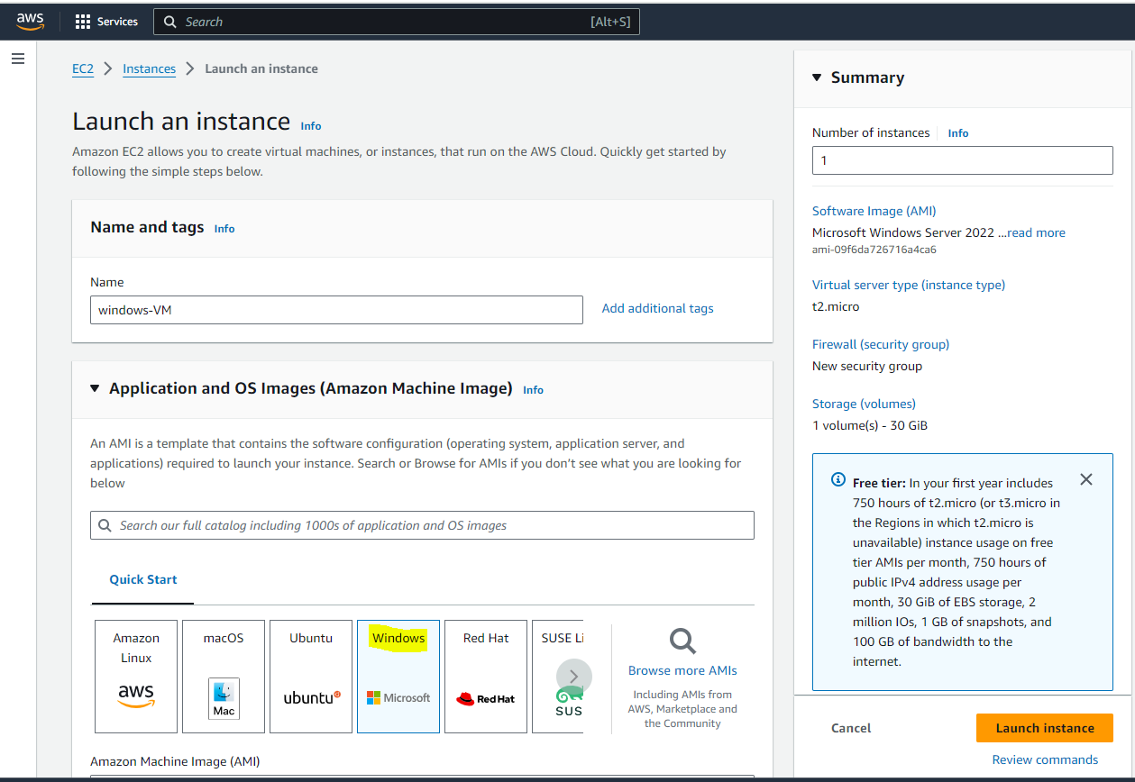

**SELECT T2 MICRO IN INSTANT TYPE AND CREATE A KEY PAIR AND LAUNCH THE INSTANCE**

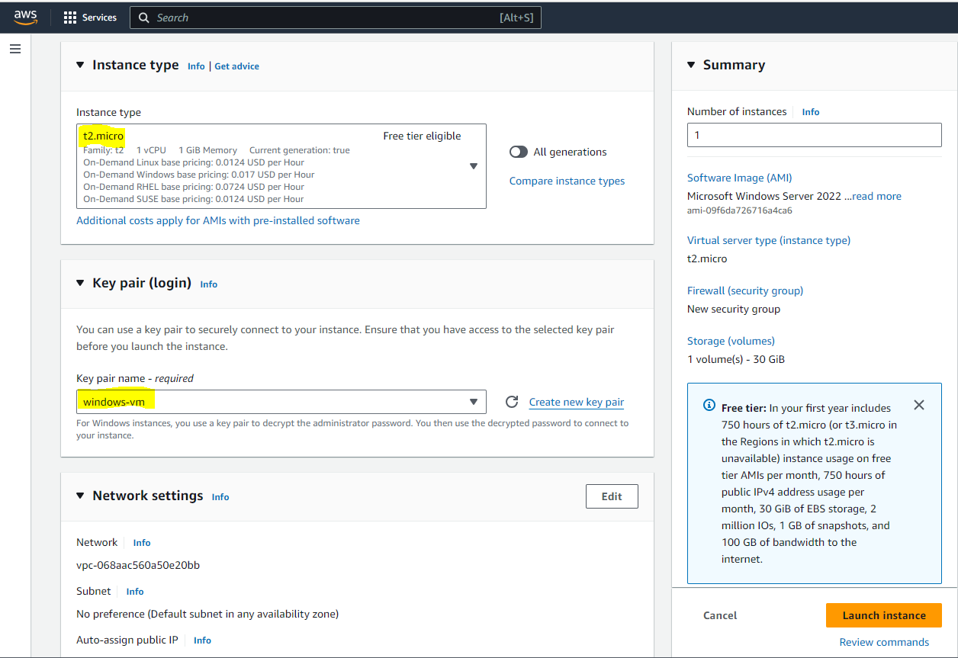

**CONNECT TO THE CREATED INSTANCE AND NAVIGATE TO RDP CLIENT GIVE DOWLOAD REMOTE DESKTOP FILE**

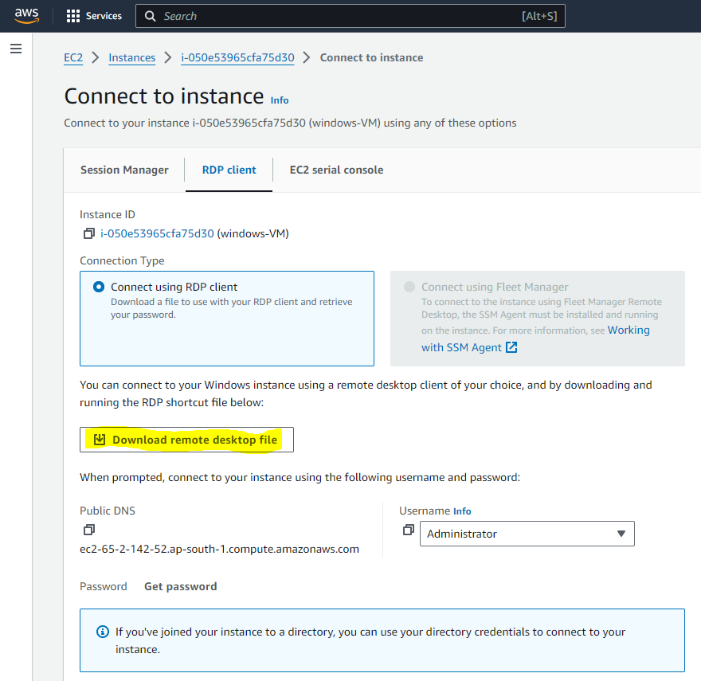

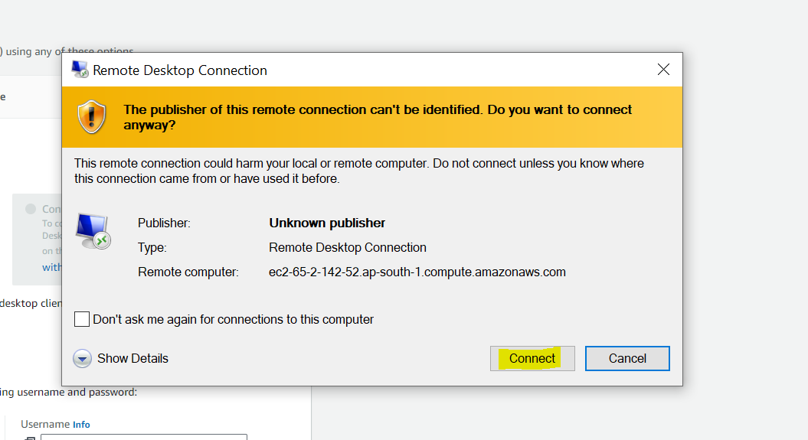

**NOW WE HAVE TO GENERATE THE PASSWORD:**

**NAVIGATE TO GET PASSWORD AND UPLOAD YOUR GENERATED .PEM KEY IN “UPLOAD PRIVATE KEY FILE” AREA AND GIVE DECRYPT PASSWORD**

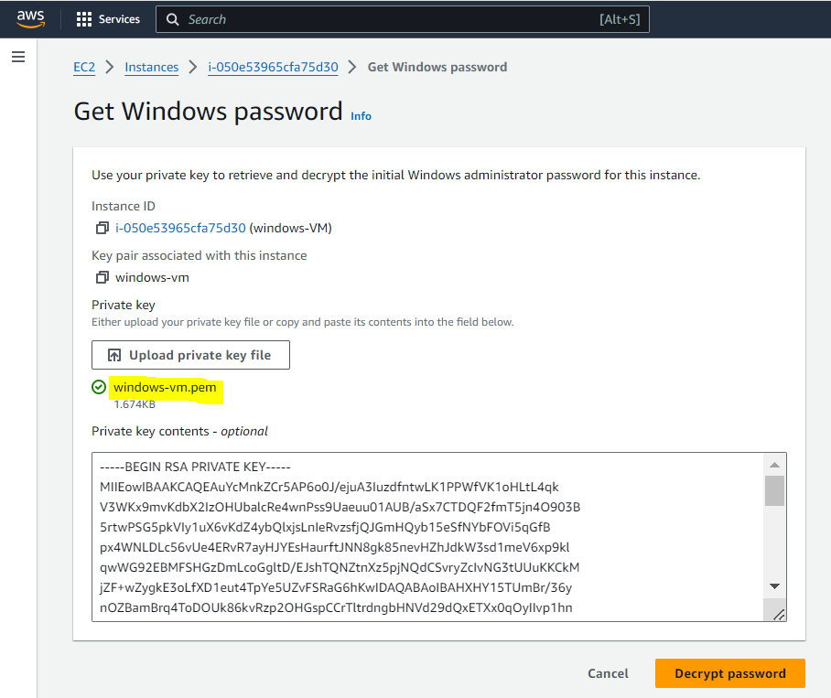

**NOW COPY AND PASTE THE GENERATED PASSWORD**

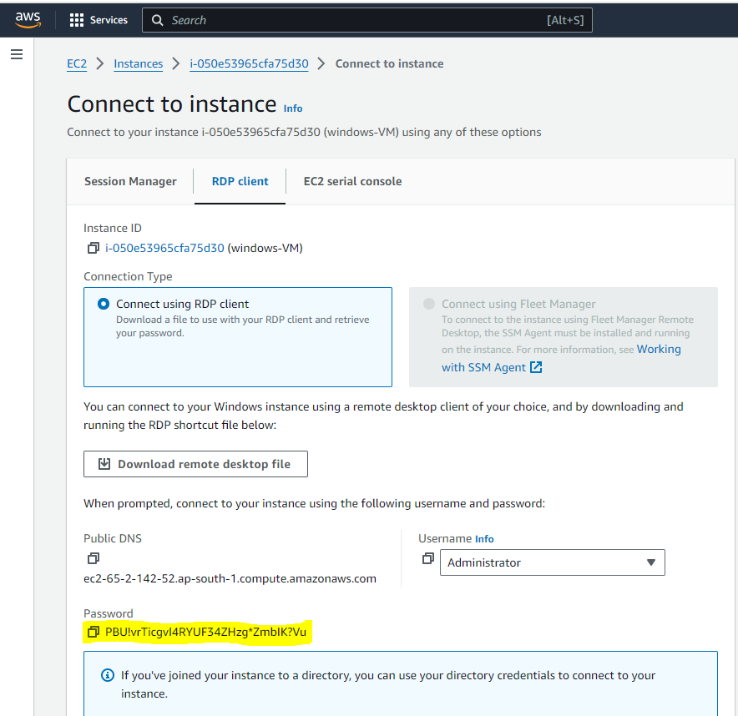

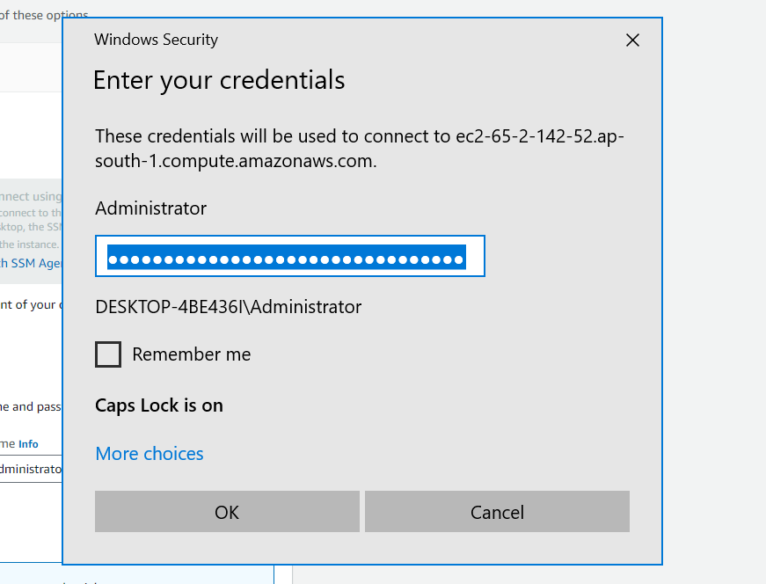

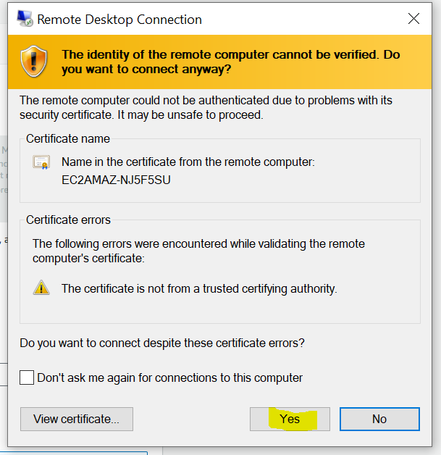

**EXTERNAL PHOTO**

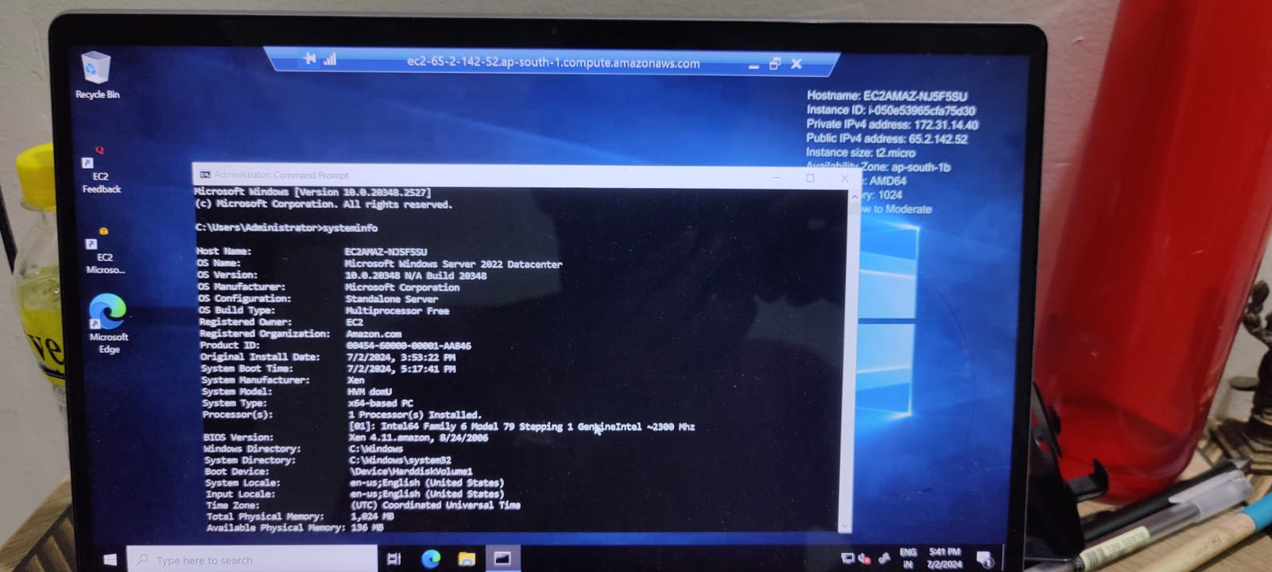

**THIS IS THE SCREENSHOT OF SYSTEM INFO IN WINDOWS VM WHICH WAS TAKEN BY USING SNIPPING TOOL INSIDE THE VM ITSELF**

